Business Attractiveness Score
(score on a scale of 1-6)
Business Factors | Rating | Considerations
Years of business operation |  | The longer the company has been established typically is more attractive to buyers
Management strength |  | Tenure of employees. Longer typically is better
Customer loyalty |  | Tenure of customers. Longer typically is better
Brand awareness |  | The longer the company has been established typically means they have a stronger brand
Good customer base (not concentrated) |  | Diverse customer base. No concentration.
Packaged IP & Technology |  | Technology, processes, IP, packaged and transferrable?
Key staff longevity |  | How tenured and experienced are your key personnel
Location/Facilities |  | Are they clean, modernized and updated
Non reliance on key manager(s) |  | Can the business run with minimal oversight of owner?
Replicable business model |  | How easy would it be to replicate the model? Hard is good.
Business systems and processes |  | Are your processes and systems updated, and documented?
Forecast Factors | Rating | Considerations
Profitability past/present |  | History of profits. How does company benchmark in industry?
Profitability growth forecast |  | Defined, well-thought out future forecast?
Revenue growth |  | History of growth?
High certainty in budget |  | How predictable are results? Proven?
Recurring revenue model |  | How predictable is demand? Proven?
Market Factors | Rating | Considerations
Market growth & potential |  | State of the specific industry and market
Industry barriers to entry |  | Fewer barriers typically mean more competition, thus less attractive
Competitive activity or advantage |  | Degree of competition for products and services
Dominant market position |  | Market position/dominance
Economic prosperity |  | State of the US economy
Investor Considerations | Rating | Considerations
Reason for selling |  | Is the sale forced due to 5Ds? Level of transition planning
Synergy and value add of buyer |  | Level of synergies for a strategic buyer
Degree of risk |  | Company specific risk
Market for business sale |  | State of the Private Capital Market. Number of potential buyers
TOTAL RATING | -
MAXIMUM RATING | 150
Attractiveness Score  (Your Total / 150 = %) | -
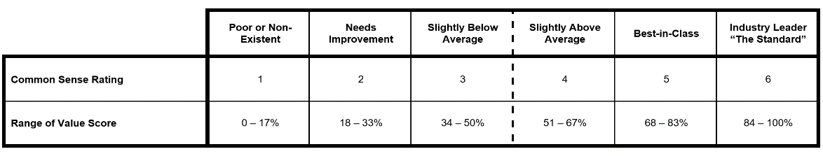
Instructions:
Step 1. Rate each category from 1-6, based on the below key:
- Bad/Nonexistent
- Needs Improvement
- Slightly Below Average
- Slightly Above Average
- Best-in-Class
- In a Class of One
Step 2. Add all ratings together and put your total in the TOTAL RATING section.
Step 3. Divide your TOTAL RATING by the MAXIMUM RATING of 150. The result will be your percentage ATTRACTIVENESS SCORE.
Example:
TOTAL RATING = 100
MAXIMUM RATING = 150
100 / 150 = .67
ATTRACTIVENESS SCORE: 67%

Copyright Exit Planning Institute

